DAY 2 :
DHCP Configuration Theory :
1.
In Cisco Packet Tracer, set up a simple network with one DHCP server and two client PCs. Configure the DHCP server to assign IP addresses automatically, then verify on each PC that it receives a different IP address from the DHCP pool.
ANS :
DHCP Server ---- Switch ---- PC0
|
└---- PC1
Configuration Steps
- Open Cisco Packet Tracer.
- Add:
  - 1 Server
  - 1 Switch (2960)
  - 2 PCs
- Connect all devices using Copper Straight-Through cables.
- Configure the Server:
  - IP Address: 192.168.1.1
  - Subnet Mask: 255.255.255.0
- Go to Services → DHCP and create a pool:
Setting | Value
Pool Name | LAN
Default Gateway | 192.168.1.1
DNS Server | 8.8.8.8
Starting IP Address | 92.168.1.100
Subnet Mask | 255.255.255.0
Maximum Users | 10

- On PC0 and PC1:
Desktop → IP Configuration → Select DHCP.
Verification
Device | Assigned IP
PC0 | 192.168.1.100
PC1 | 192.168.1.101

Observation: Both PCs receive different IP addresses automatically from the DHCP pool.
2.
Draw a sequence diagram (hand-drawn or digital) that clearly shows each step of the DHCP process: Discover, Offer, Request, and Acknowledge, labeling the sender and receiver at each stage.<br><br><em><strong>Hint:</strong> Use arrows to show the direction of each message between client and server.</em>
ANS :
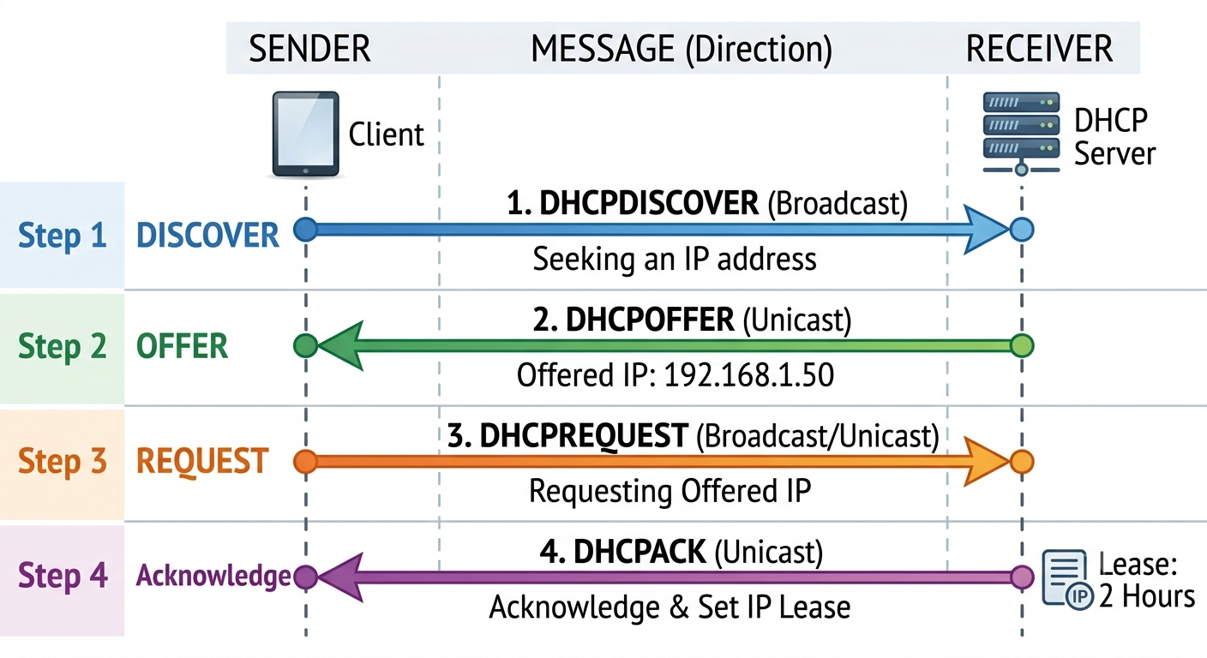

3.
Change the DHCP pool range on your Cisco Packet Tracer DHCP server so that only one IP address is available. Add two PCs and observe what happens when both try to get an IP address. Take a screenshot of the result and explain in 2-3 lines why only one PC succeeds.
ANS :
Configuration
Set the DHCP pool as:
Setting | Value
Starting IP | 192.168.1.100
Maximum Users | 1

Add two PCs and set both to DHCP.
Device | IP Address
PC0 | 192.168.1.100
PC1 | 0.0.0.0 (No IP Assigned)

Only one IP address exists in the DHCP pool, so the first PC receives 192.168.1.100. When the second PC requests an address, no free IP addresses remain, so the DHCP server cannot assign one and the PC fails to obtain an IP configuration.
4.
Simulate a Zomato-style restaurant WiFi scenario in Cisco Packet Tracer: configure a DHCP server to provide IP addresses to both a laptop and a smartphone (use a generic PC as smartphone). Show the assigned IPs and explain why DHCP is useful in this situation.
ANS :
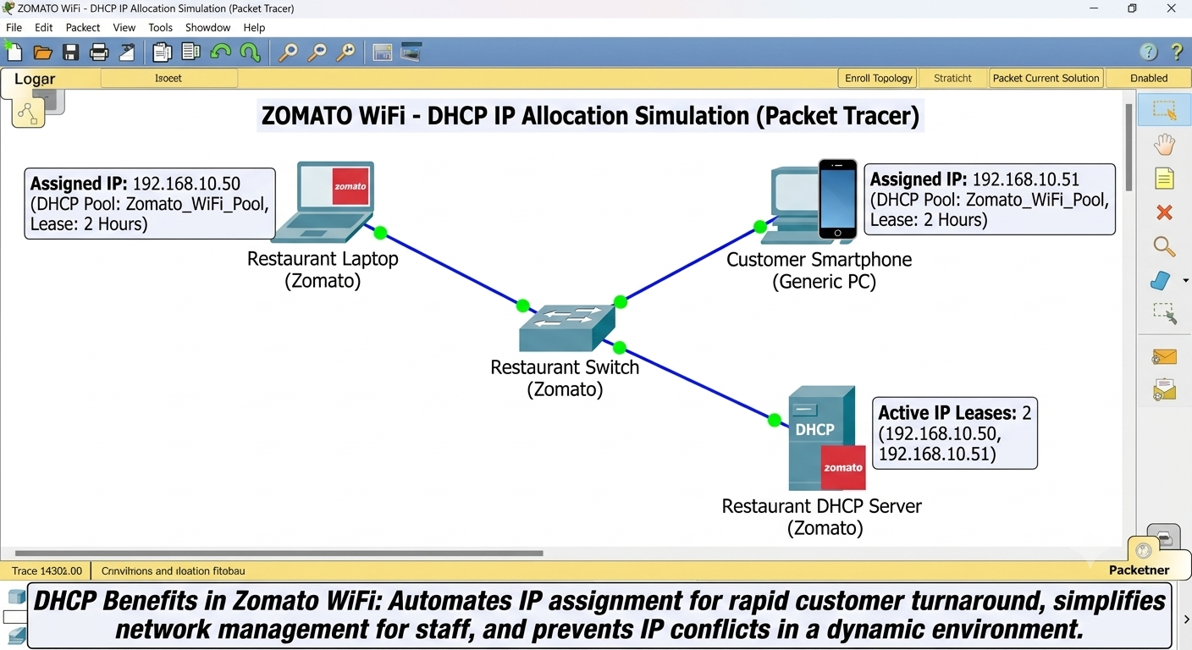
Why DHCP is Useful for Zomato Restaurant WiFi :
- Automatic IP assignment: Customers do not need to configure network settings manually.
- Prevents IP conflicts: Each device receives a unique IP address.
- Easy management: Staff do not need to assign IP addresses one by one.
- Supports many customers: New devices can quickly join and receive network settings automatically.

